how to compare and select time series models based on predictive performance
- classical time series models,
- supervised models,
- and deep learning-based models.
Time series is a special type of data set in which one or more variables are measured over time.\
In time series, however, observations are measured over time. Each data point in your data set corresponds to a point in time. This means that there is a relation between different data points of your dataset. This has important implications for the types of machine learning algorithms that you can apply to the time series dataset.
https://towardsdatascience.com/time-series-analysis-and-forecasting-of-web-service-metrics-1e15d7fb72c2https://towardsdatascience.com/time-series-analysis-and-forecasting-of-web-service-metrics-1e15d7fb72c2

- https://cran.r-project.org/web/packages/imputeTime-Series/vignettes/imputeTime-Series-Time-Series-Missing-Value-Imputation-in-R.pdf
- https://neptune.ai/blog/anomaly-detection-in-time-series
- https://machinelearningmastery.com/resample-interpolate-time-series-data-python/
- https://otexts.com/fpp2/missing-outliers.html
- https://otexts.com/fpp2/stl.html
- https://otexts.com/fpp2/arima.html
- https://otexts.com/fpp2/expsmooth.html
- https://www.advancinganalytics.co.uk/blog/2021/06/22/10-incredibly-useful-time-series-forecasting-algorithms
- https://www.analyticsvidhya.com/blog/2021/05/detecting-and-treating-outliers-treating-the-odd-one-out/
- https://otexts.com/fpp2/missing-outliers.html
- https://www.rdocumentation.org/packages/forecast/versions/8.3/topics/tsclean
- https://www.researchgate.net/publication/332079043_Best_Practices_for_Time_Series_Forecasting_Tutorial_Paper
- https://www.anodot.com/blog/time-series-forecasting/
- https://www.researchgate.net/publication/274315018_PERFORMANCE_COMPARISON_OF_TIME_SERIES_DATA_USING_PREDICTIVE_DATA_MINING_TECHNIQUES_Advances_in_Information_Mining
- https://www.researchgate.net/publication/274315018_PERFORMANCE_COMPARISON_OF_TIME_SERIES_DATA_USING_PREDICTIVE_DATA_MINING_TECHNIQUES_Advances_in_Information_Mining

Provide confidence intervals on top of predictions.
As previously stated, forecasts are predictions that always include confidence intervals, usually 80% and 95%. Alternatively, you could choose to use the standard deviation of the residuals as the sample standard deviation, allowing the confidence intervals to be calculated using an appropriate distribution, like the normal or exponential.
For some models, e.g., neural networks, which are not based on probability distributions, you can run simulations of the forecasts and calculate confidence intervals from the distribution of the simulations.

Preparing the Data
We will use tf.datasets to prepare the data. The general strategy is to clean, scale, and split the data before creating the tf.dataset object. These steps can alternatively be done within the tf.dataset itself.
Cleaning data: Fill any missing values with a linear interpolation of the value. Same as done in the persistence dataset.
Scaling data: In all cases the data is min max scaled.
Features: As part of this simple analysis of models two feature sets are prepared. The univariate that contains energy consumption data only. The multivariate that contains energy consumption, price, day of the week, and month of the year.
Splitting data: One year of test data (8769 hourly samples) is put aside to evaluate all the models. The train and validation sets are created with a 65/35 split, resulting in 9207 validation samples - just over one year.
mae error_mw
dnn 0.117158 3363.850678
cnn 0.081110 2328.828899
lstm 0.085401 2452.055694
lstm_cnn 0.083816 2406.540358
lstm_skip 0.089378 2566.219683

Types of Time Series Data
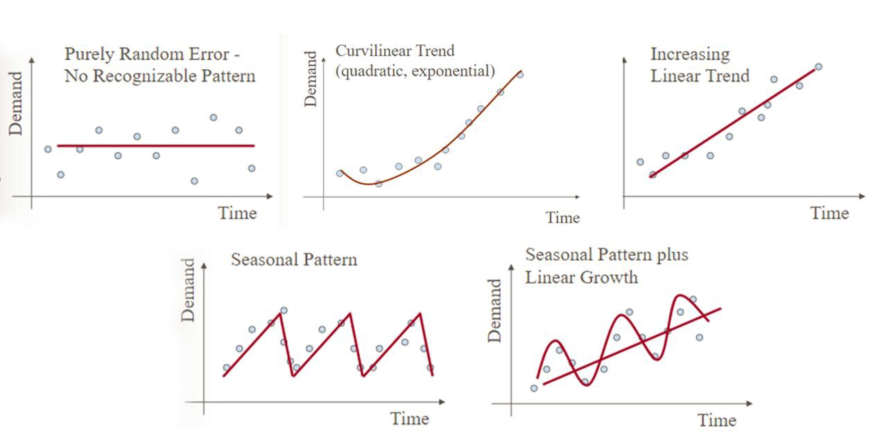
reference: https://engineering.99x.io/time-series-forecasting-in-machine-learning-3972f7a7a467

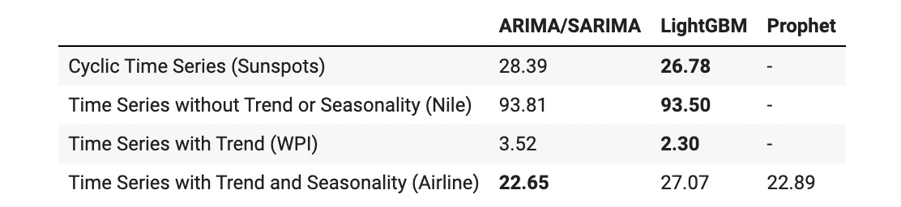
Model Forecast MAE by Time Series Dataset

Table 1. The algorithms that will be evaluated in the study. Algorithm Pros Cons Recurrent Neural Network Simpler than LSTM fewer hyperparameters that can be tuned. Unable to use more than ~10 previous steps in time because of vanishing- and exploding gradient problems. Long-Short Term Memory Network Does not risk vanishing gradient. Can use any number of independent variables and any number of previous time steps. Needs a lot of training data. There is no deterministic developmental process, must be developed individually for each dataset. There is loss of data between each module. Temporal Convolutional Network Number of weights increase linearly while receptive field increase exponentially. Has only been studies for sequential problems never for time series. Takes more time to train than RNN and LSTM. ARIMA Standardized developmental process. Good insight into how the algorithm works. No need for hyperparameter tuning. Relatively simple model. Data must be stationary. Hidden Markov Model Good at modelling stochastic behavior. Cannot use independent variables. Difficult to develop due to weak library support in R and Python.

